Part A

1. MaxVal Nassi

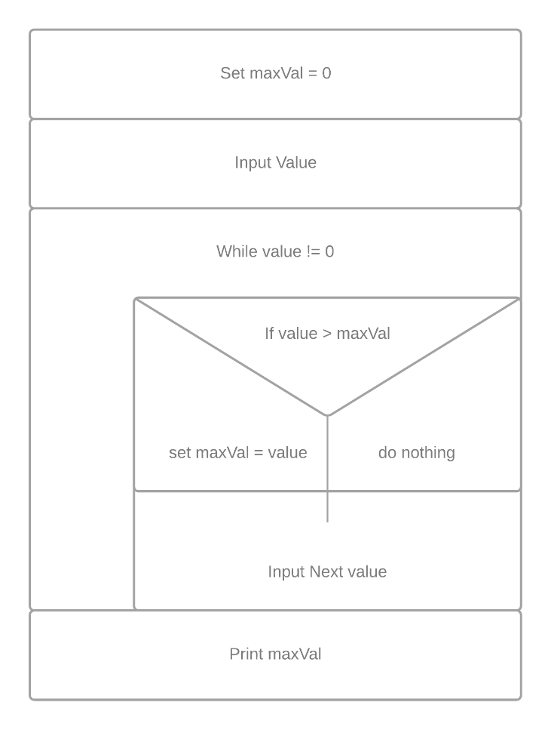

Linear Search - Nassi

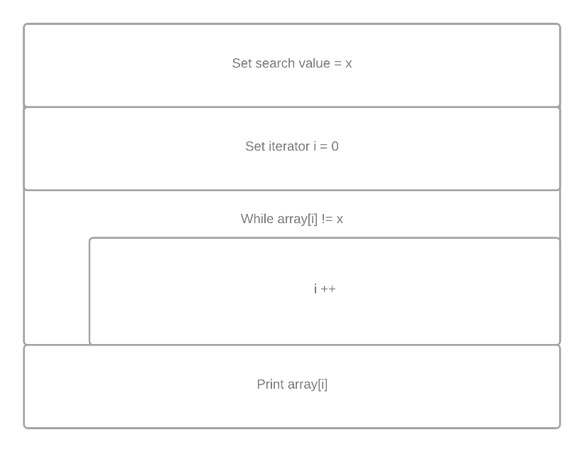

1. Max Val Flowchart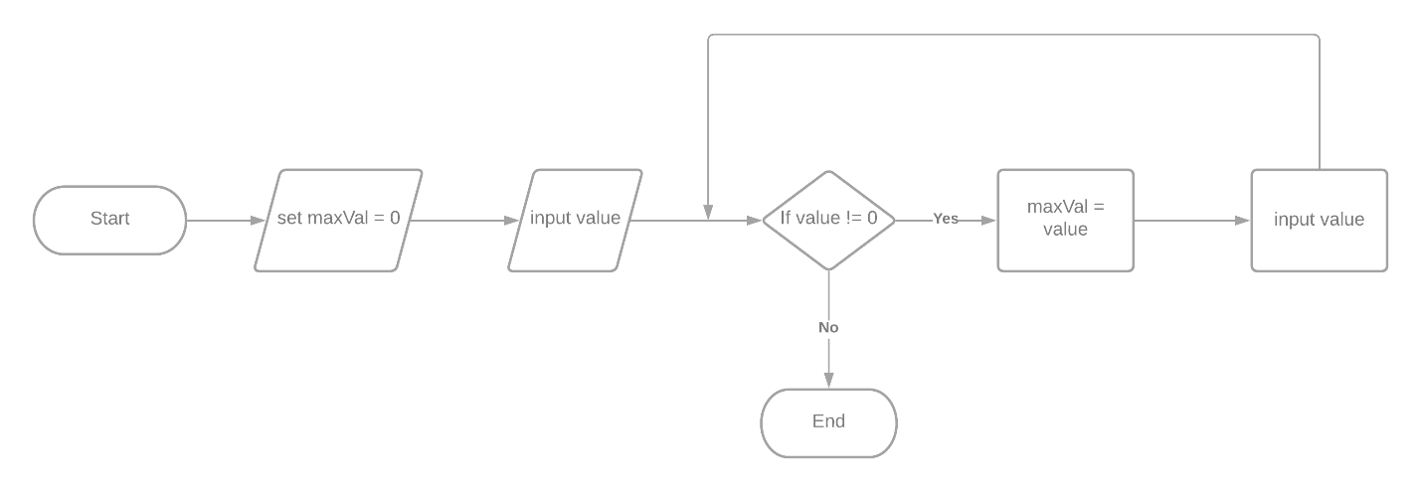

Linear Search Flowchart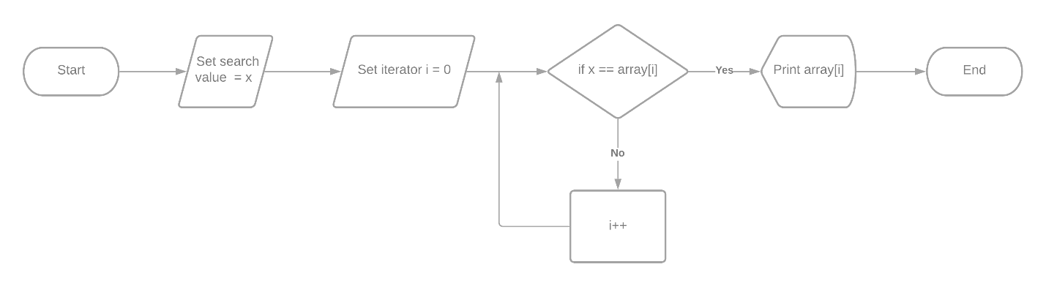

1. Pseudocode

// #3 Binary Search

SET searchVal = x

SET flag == TRUE

WHILE( TRUE ){

IF( node.val() == x){

SET flag == FALSE

}

ELIF( node.val() < x ){

node = node.right()

}

ELIF( node.val() > x ){

node = node.left()

}

}

return node.val()

// #2 Linear Search

SET searchVal = x

SET i = 0

WHILE( array[i] != x ){

i++

}

PRINT array[i]

// #1 MaxVal

SET maxVal = 0

INPUT value

WHILE( value != 0){

IF( value > maxVal){

SET maxVal = value

}

INPUT value

}

PRINT maxVal

Part B

1.

|  |  |  |  |  |
| --- | --- | --- | --- | --- |
| Condition | Rule 1 | Rule 2 | Rule 3 | Rule 4 |
| Month > =1 | Y | Y | N | N |
| Month < =12 | Y | N | Y | N |
| Valid? | Y | N | N | N |

2.

|  |  |  |  |  |
| --- | --- | --- | --- | --- |
| Condition | Rule 1 | Rule 2 | Rule 3 | Rule 4 |
| Hourly? | Y | Y | N | N |
| Hours worked > 40? | Y | N | Y | N |
| Absence Report | N | Y | N | N |
| Overtime Pay | Y | N | N | N |

3.

|  |  |  |  |  |  |  |  |  |
| --- | --- | --- | --- | --- | --- | --- | --- | --- |
| Condition | Rule 1 | Rule 2 | Rule 3 | Rule 4 | Rule 5 | Rule 6 | Rule 7 | Rule 8 |
| Student? | Y | Y | Y | Y | N | N | N | N |
| Garage? | Y | Y | N | N | Y | Y | N | N |
| Small Vehicle? | Y | N | Y | N | Y | N | Y | N |
| Rate $150 | N | N | N | N | Y | N | Y | N |
| Rate $200 | N | N | N | N | N | N | N | Y |
| Rate $250 | N | N | Y | Y | N | N | N | N |
| Rate $350 | Y | N | N | N | N | N | N | N |
| Rate $400 | N | N | N | N | N | N | N | N |